

**ROVER**

Tasneem Yousry Software member

Abdelrahman Elshabiny Software member

Ahmed Reda Software member

Amr Naguib Hardware member

Yara Adel Hardware member

**Image processing**

**1)Line follower:**

The code begins by first converting the image to grayscale and then thresholding it. Next, it finds the largest contour in the image and fills it with white. After that, it inverts the image and applies the MOG2 background subtraction algorithm. Finally, it inverts the image again and removes the background from all areas that are not surrounded by the white outline.

Secondly, it reads the frames coming from the phone's camera, then resizes and removes the background in each frame. The function then finds the maximum contour and calculates its center of gravity, comparing the values to the width of the image and deciding the direction the robot should take.

**2)Shape detection**

The function first works by applying filters to remove the noise, then it loops over the contours, when it finds a contour that does not have a parent, it skips this iteration.

Then it detects the shape according to number of vertices “len(approx)”.

**3)Color detection**

First, every color’s range is defined, and checks whether the center of the contour lies in the range of color or not.

Then this function checks each color, if the detection returns true, then it will increment the color by one, else it will check another color.

**Hardware**

**Connections**

Prototype on breadboard to test motion with soft wear.  
Pcb to avoid wrong Connection and noise from wires.  
 PCB Design

**Schematics**   
To declare each component Connection in pcb  it consists of some blocks.

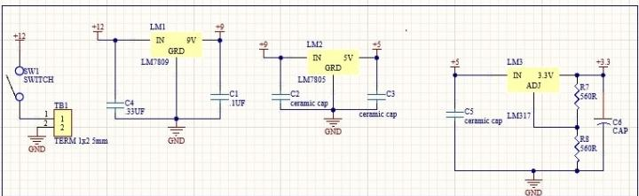blocks  
Power block .  
Mcu block.  
Sensors block .  
Motion block .  
**Power block   
Components**Lm7809:  
To regulate voltage from 12 to 9v.  
Lm7805:  
To regulate voltage from 9 to 5v.  
Lm7805:  
To regulate voltage from 5 to 3.3v.

**Mcu Block**  
To control sensors and motors.

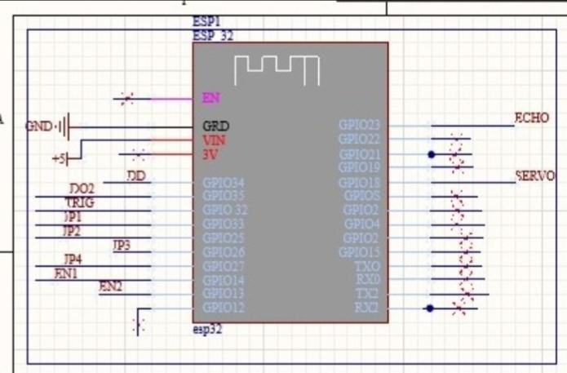

**Sensors Block**   
**Components**  
Encoder.  
To draw line for the robot.  
Ultrasonic .  
To Know object  distance from camera.

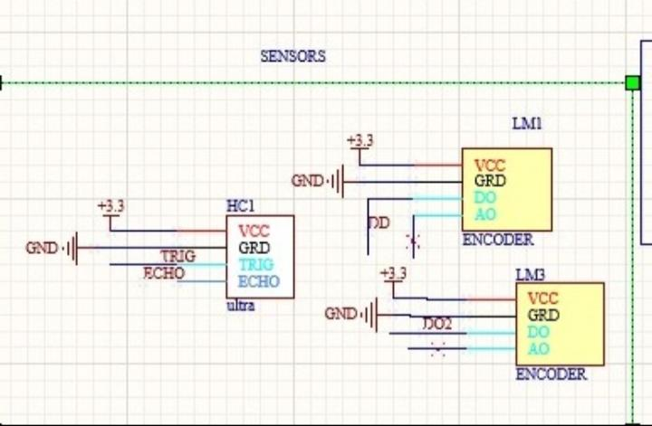

**Motion Block   
Components**L293D.  
To control Motion of  dc motors.  
Dc motors.  
Servo motor .

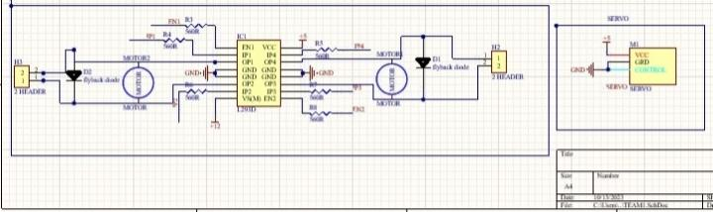

**PCB design**

